**Script postman**

**Account**

GET: <http://localhost:8080/rest/accounts>

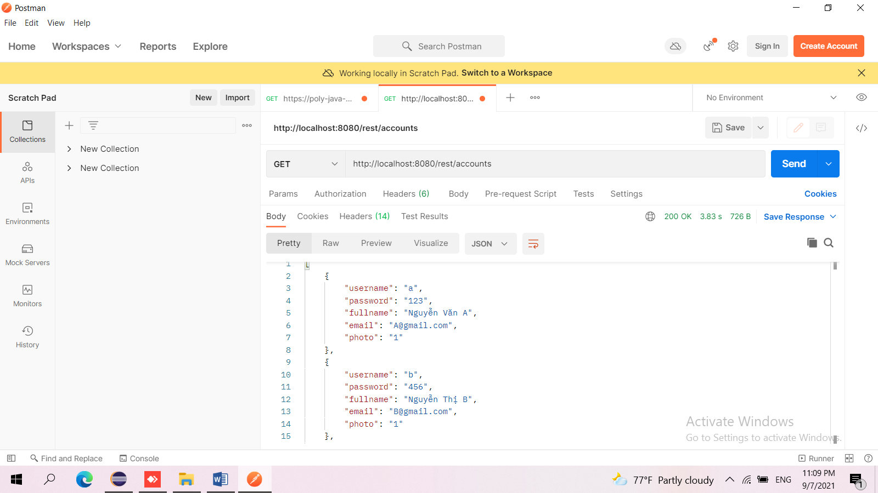POST: <http://localhost:8080/rest/accounts>

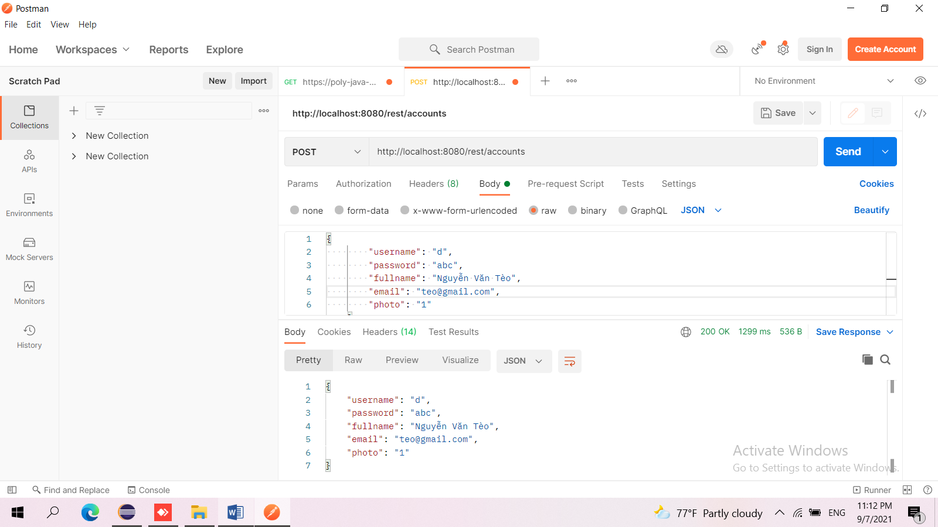

PUT: <http://localhost:8080/rest/accounts/d>

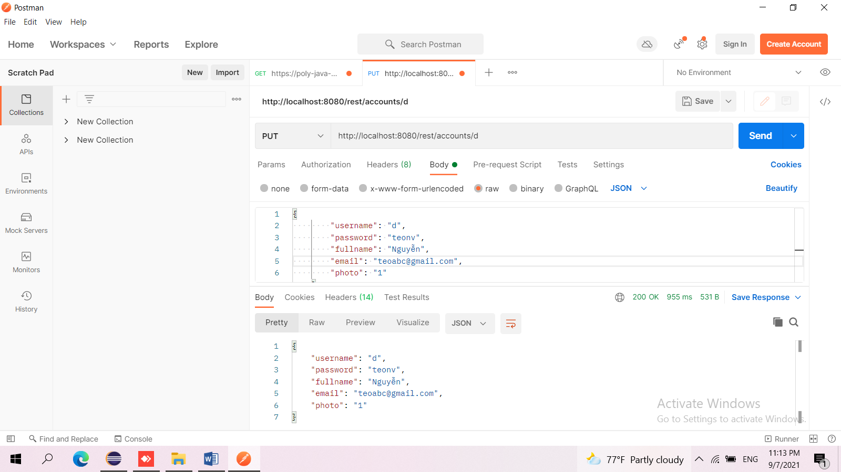

DELETE: [http://localhost:8080/rest/accounts/d](http://localhost:8080/rest/accounts/duypkpc01003)

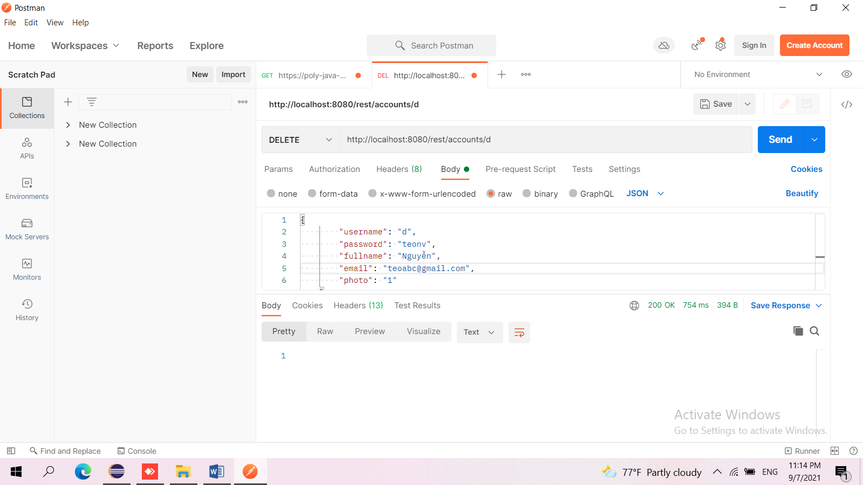

**Products**

GET: <http://localhost:8080/rest/products>

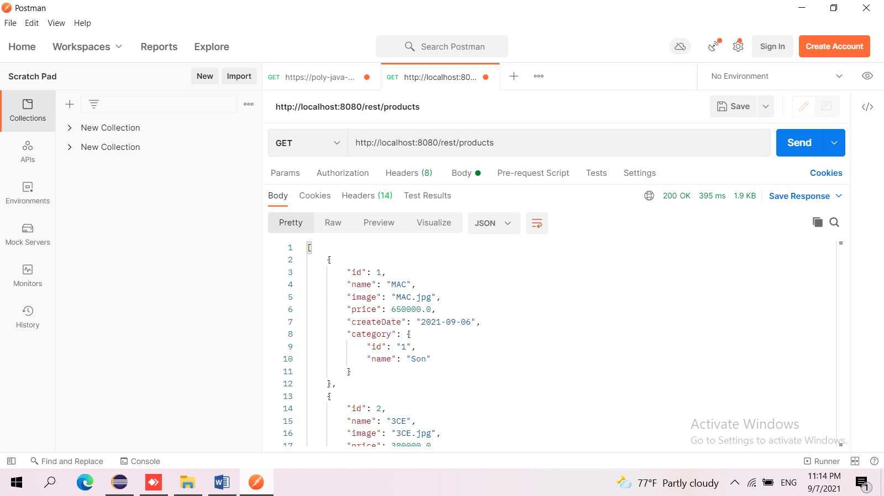

POST: <http://localhost:8080/rest/products>

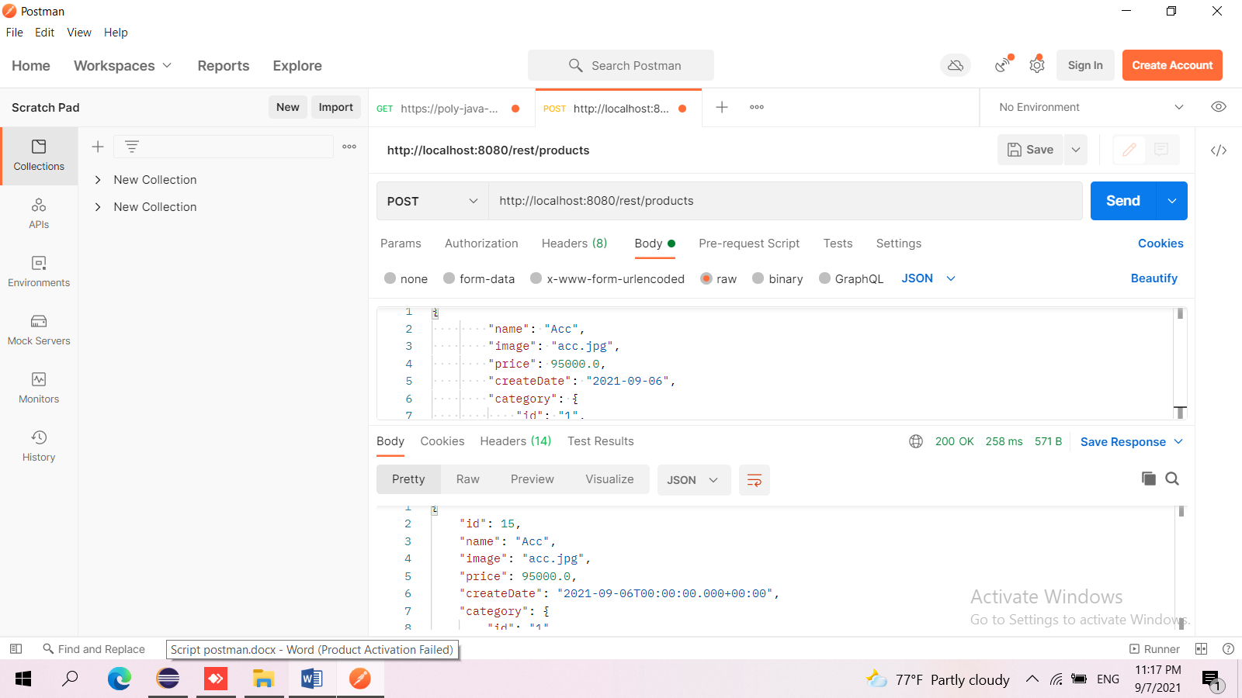

PUT: <http://localhost:8080/rest/products/15>

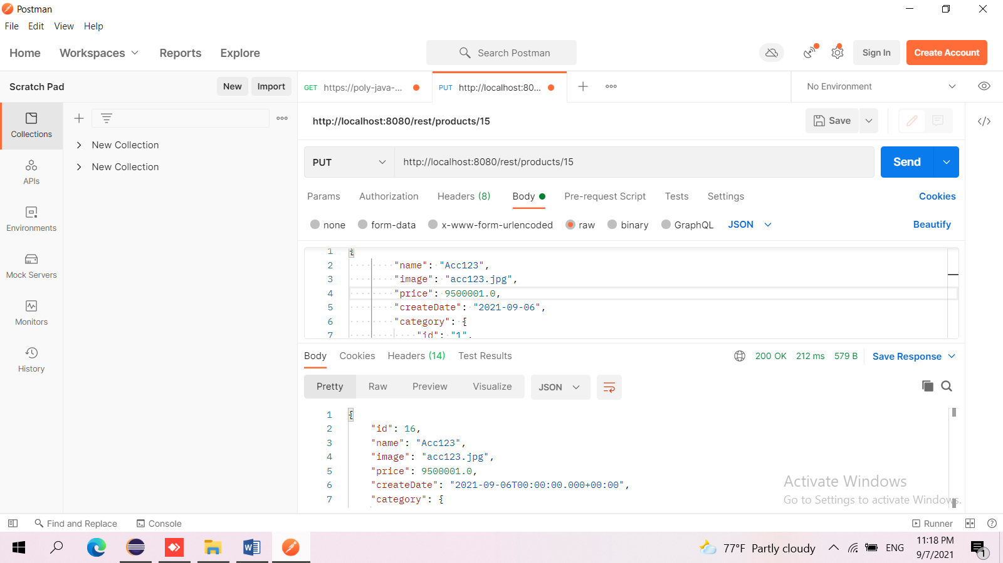

DELETE: <http://localhost:8080/rest/products/15>

